**D. Y. Patil College of College of Engineering and Technology, Kolhapur**

**Department of Computer Science & Engineering**

**Class: SY-A Subject: AOOC**

**Experiment no: 15**

**Group No. 30 Mini Project**

**Title of Mini-Project: Online Shopping Cart**

**Problem Statement:**

Managing online product purchases efficiently is crucial for modern businesses. The existing manual or simplistic digital systems often lack user authentication, dynamic product handling, and order records. There is a need for a stylish and interactive shopping cart application that allows:

* Customers to log in, register, browse products, add to cart, and checkout.
* Admins to manage the product catalog (add, update, delete).
* Orders to be saved persistently for future use.

**Introduction:**

The **Shopping Cart** is a Java Swing-based desktop application that simulates an online shopping experience. It enables users to log in or register, browse a list of products, add items to their cart, and generate a billing summary at checkout. Administrators have additional privileges to manage the product inventory dynamically.

This application uses:

* **Java Swing** for GUI,
* **CardLayout** for smooth panel switching,
* **HashMap & ArrayLists** for user and product data
* **File I/O** for storing orders persistently.

**System Architecture:**

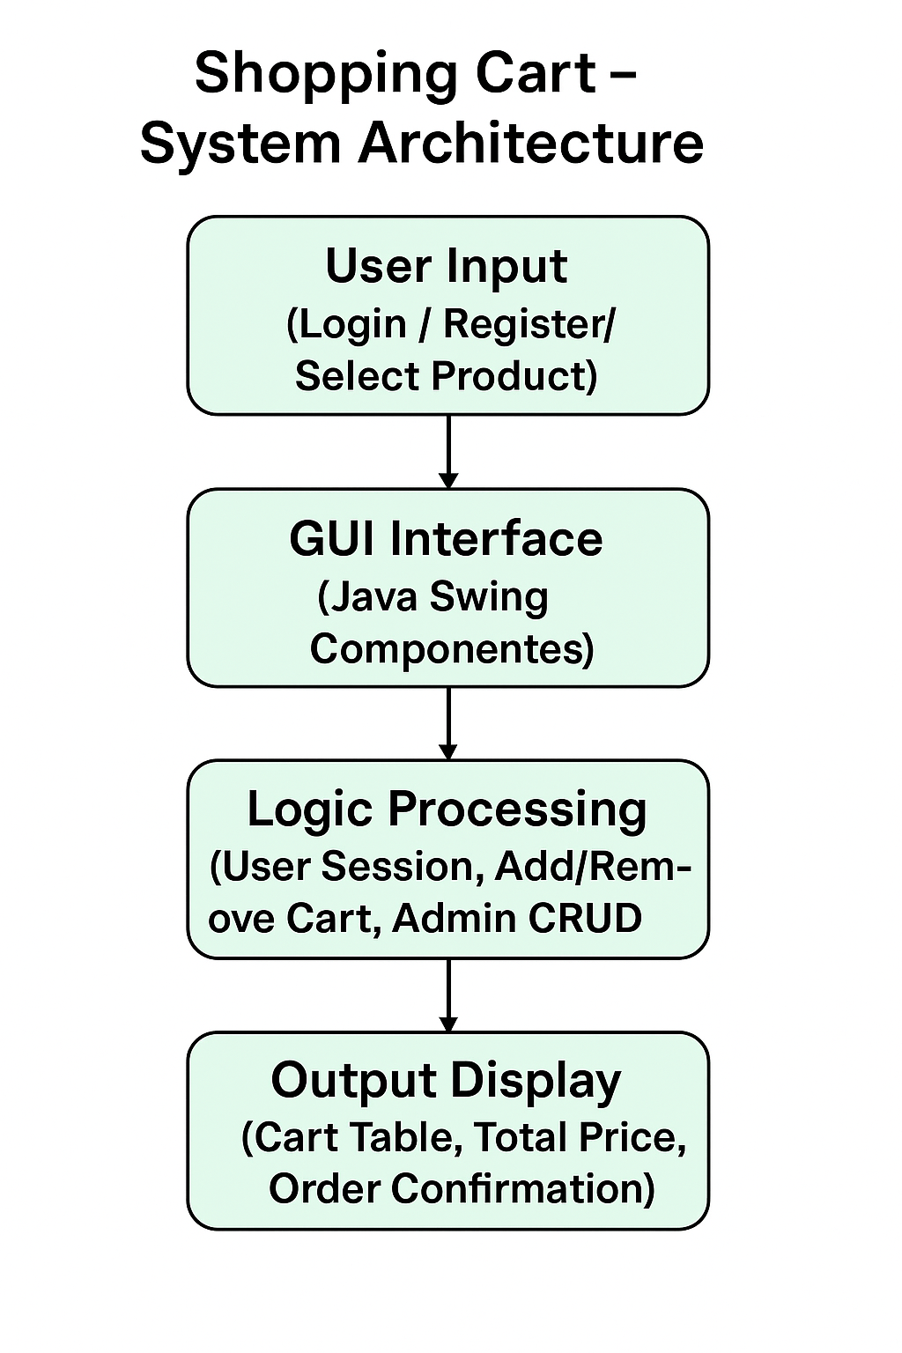

**Module description or working of system:**

1. User logs in or registers with a username and password.
2. Displays list of available products in the shop.
3. User adds desired products to the shopping cart.
4. System calculates and shows the total price dynamically.
5. All order records are saved using Java File I/O(Order.txt).

**Screenshots:**



**Group Members:**

|  |  |  |  |
| --- | --- | --- | --- |
| **Unique id** | **Roll no** | **Name of Student** | **Sign** |
| **EN23247762** | **132** | **Rohit Mahadev Patil** |  |
| **EN23210246** | **134** | **Rohit Subhash Harne** |  |
| **EN23191574** | **138** | **Omkar Dhanaji Shetake** |  |
| **EN23182956** | **140** | **Vishal Vijay Chougale** |  |